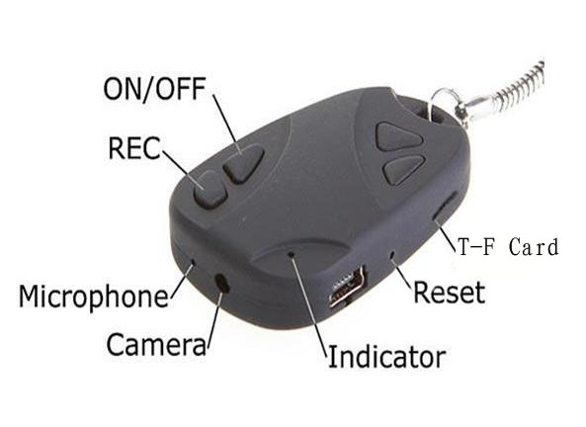

ON/OFF – Power Button
REC – Shutter Button
Indicator – LED light
(Note: When you first receive your camera, ensure that you have a memory card inserted in the camera and that the camera is turned off. Then, plug it into your computer to charge for at least 2-3 hours)

For the most up to date info and troubleshooting please see: chucklohr.com/808

GENERAL USE:
-insert any microSD card up to 16GB in size into the card slot

-to turn the camera on: Press and hold the power button until LED lights up

-to take a picture: press the shutter button once (A picture is taken successfully if the LED goes off for a brief moment and then lights up again)

-to take a video: press and hold the shutter button until the LED blinks rapidly a few times then release the shutter button (The LED should remain off while video is being captured). To stop the video briefly press the shutter button (the LED should light up again to indicate that the video capturing has been stopped)

-to turn off the camera: press and hold the power button until the LED goes off

CONNECTING THE CAMERA TO A COMPUTER:

-to access pictures and video from microSD card: ensure the camera is off; plug the small end of the USB cable into the camera and the other end into a USB port on your computer. The first time you do this your computer should automatically install the required drivers and the camera should show up as a removable disk drive on your system from then on. The pictures and video can be viewed on this drive. Alternatively the microSD card can be removed from the camera and inserted into a compatible adapter and/ore card reader and then plugged into your computer.

-to use the camera as a webcam: First, install the drivers found on the included CD-ROM* or that can be downloaded (and then uncompressed/unzipped) from my blog on RCGroups**. Install by double-clicking the setup file.
Next, ensure that the camera is off and that it has a microSD card in the card slot; press and hold the shutter button while plugging in the USB cable. The camera will then load as a webcam on your computer. Please note that most of these cameras have a dark oval shadow on the left side of the picture when using it as a webcam, I am not sure why this is.
When you are doen using the webcam, disconnect the camera from the computer and press the reset button on the camera otherwise it will not turn off.

* “CD-driveletter”:\ user manual\key chain camera\SPCA1528_V2220_MultiLan_090217\

** http://www.rcgroups.com/forums/member.php?u=108380
CHARGING:

-Plug the small end of the USB cable into your camera and the other end into a USB port on your computer. The LED should light up and either remain on or flash. The flashing apparently implies that it is charging while a steady light is supposed to mean it is done charging. I have one camera that shows a steady light regardless of its state of charge and one that flashes for a few minutes. So what I do is just make sure there is some sort of light when I plug the camera into my USB port and just leave the camera plugged in for an hour or 2 after having used it a few times and have not yet had a flat battery.

DATE AND TIME SETTING:
(I try my best to get the date and time set correctly before sending the camera out to you but if for some reason I missed it or Daylight savings comes around…)

-download and edit the “tag.txt” file from the first post in the for sale threads on RCGroups or Wattflyer (see previous page for link) or create your own “tag.txt” file and then edit and paste the following text into it: (there needs to be a blank space at the end of each line in the file)

[date]
2010/02/27
08:01:00

Copy the “tag.txt” file to your microSD card and then remove the camera from the computer and turn it off and then on. The date and time should now be set and the “tag.txt” file should no longer appear on your microSD card.

THE RESET BUTTON:
If all else fails, press the reset button, it solves most issues.

FORMATTING THE MEMORY CARD:
There have been a couple of occasions where formatting the memory card has solved an apparent problem. To format your card, insert it into your camera, ensure the camera is turned off and plug it into an open USB port. On a windows system go to your “My Computer” folder. There you should see a drive representing the memory card in your camera, usually named “Removable Disk” and a drive letter. To format the drive, right click on the drive name and select “Format” then click OK and OK again. After the format is complete, unplug the camera from the USB port and try using it again. On a MAC I have no idea how to go about formatting the card, but since it’s a MAC it’s supposed to be straight forward and easy right?

TROUBLESHOOTING:
-My camera won’t turn on
Most likely the battery is flat. Press the reset button and try again. If that does not work plug it in to your computer and let it charge for an hour or 2.

-My camera won’t take any video (or possibly pictures)
If the camera turns on and off OK but won’t take video, check to see if your memory card is full. If the memory card is full, delete or move some files from it and try again. If it still does not work format the memory card but right clicking on the drive letter of the camera/card reader on your computer and selecting “Format”. (Note, if your memory card is say 4GB, then the max useable space will actually be a little less than that so if your card says it has 3.xxGB used it might be full)
If formatting does not help try another memory card or contact me, my email address is at the end of this manual.

-My camera is dead and won’t do anything
If you unplug your camera from the USB port and the little LED goes off and your camera does not respond to any button presses or the reset button. Try plugging it back into the USB port and when the little LED turns on immediately unplug it again. The LED should then remain on and your camera should work as normal.

This manual is a work in progress and I hope this makes some sense. If there is something I should add or change, or if you have any questions or problems not covered in this manual please feel free to contact me on RCGroups or Wattflyer (Username: bobskinner) or by email at: bobskinner@gmail.com

