Foam tail of the Topsky DLG
installation Guide

- cut the frame from wood board
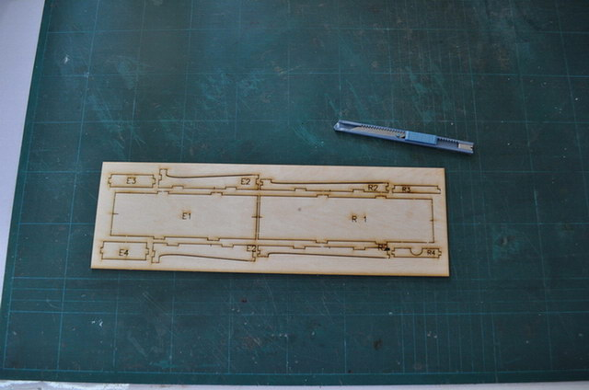
- use CA to built the tail installation frame. R1-R4 for rudder ,and E1-E4 for elevator

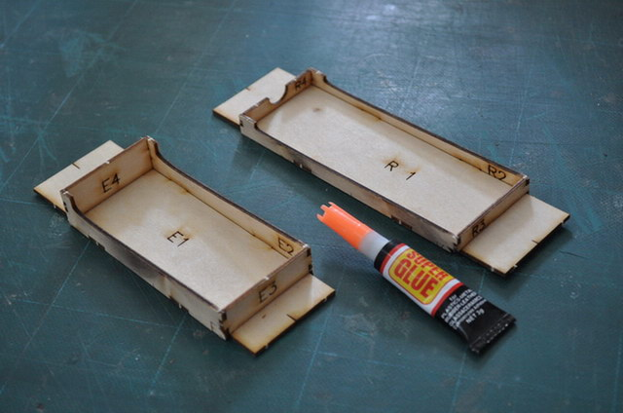
- cut a slot about 27x10 mm on the rudder

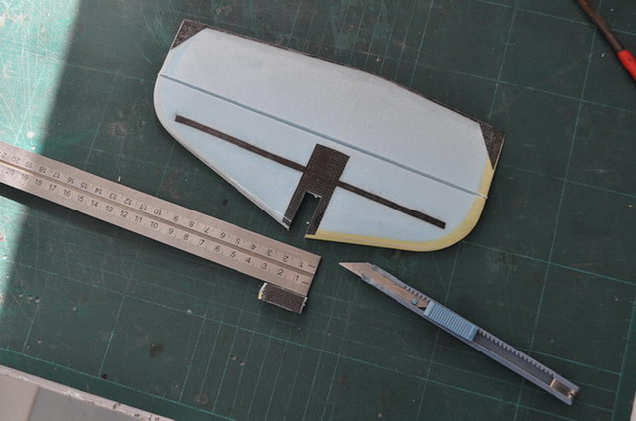
- sand a little slot in the center at the end of the boom ,about 5mm width.

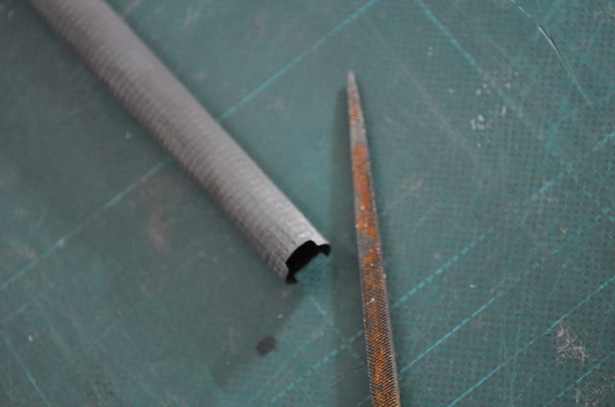
- pre-connect the boom and rudder, maybe you need to trim the rudder slot width

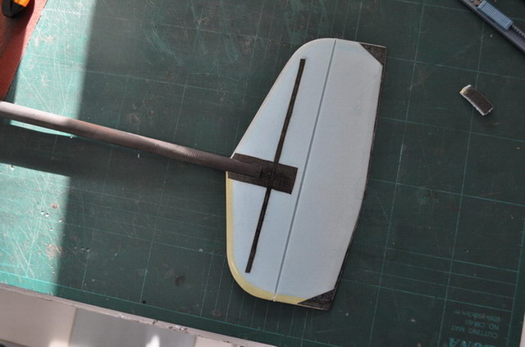
- tape the paper on the table, and draw a long line

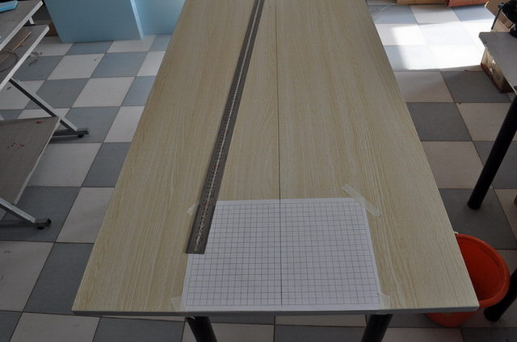
- place the tail frame on the center of the paper

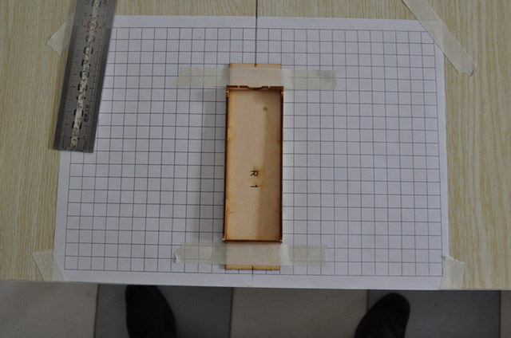
- please notice the slot on the side of frame must on the paper line

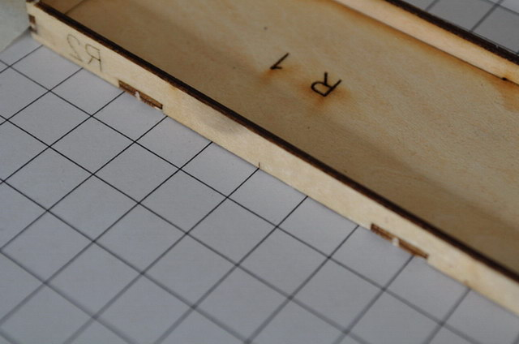
- place the rudder and boom on the frame

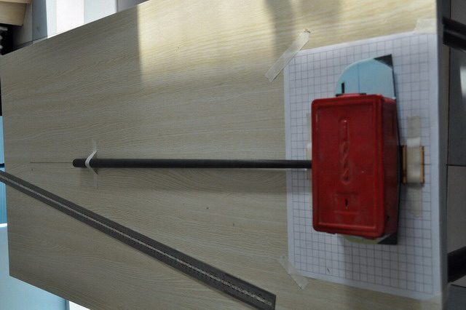
- check the following :
  - hinge slot parallel to the paper line

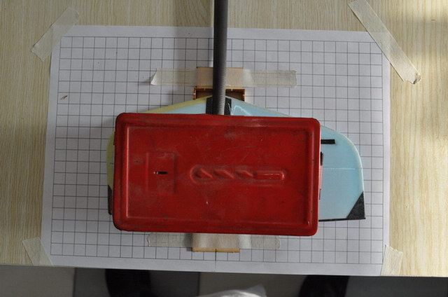
  - downside of the airfoil fit the frame very good
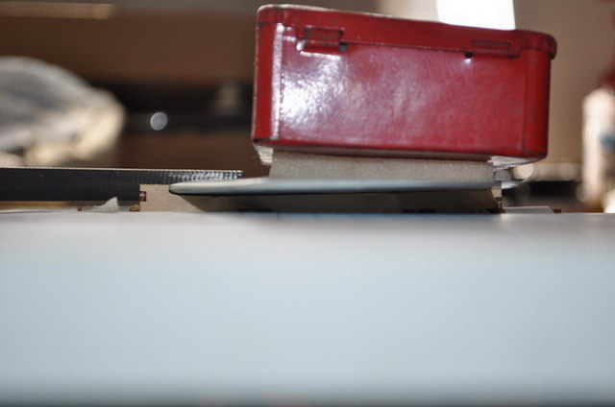
  - boom is parallel to the long line on the table

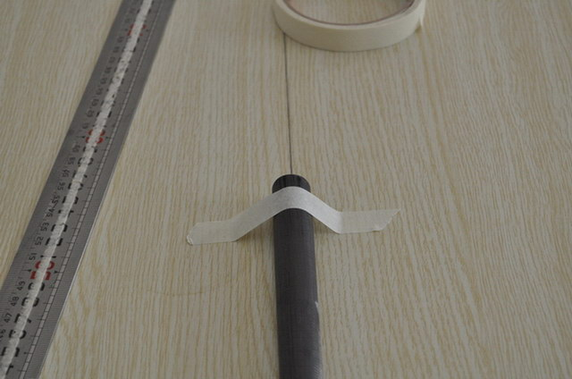
- use the 6 minuts glue

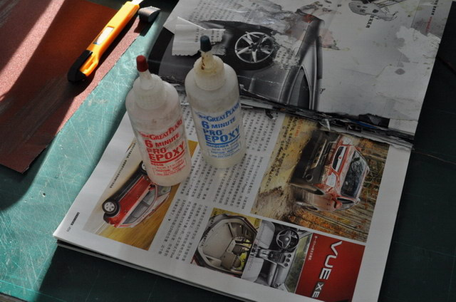

- use a little glue to fix the boom and rudder

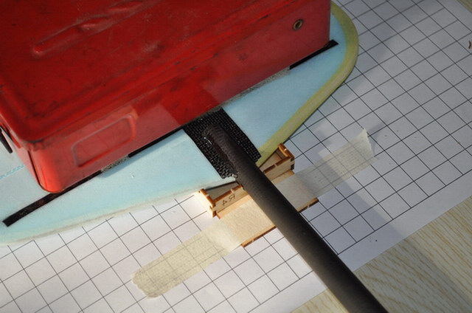
- after several minutes , fix another side of the rudder with a little 6 minutes glue

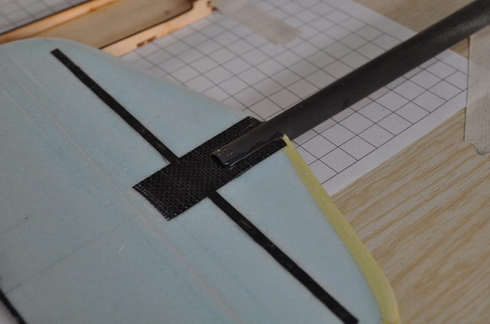
- sand the downside of the elevator platform

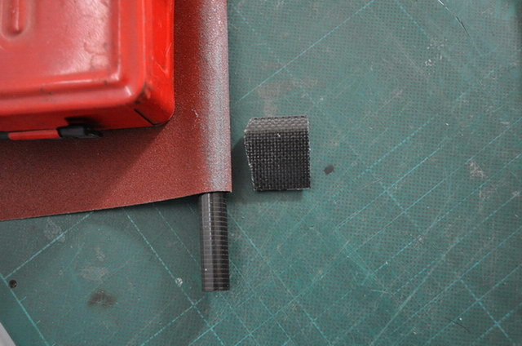
- sand the upside of the elevator platform

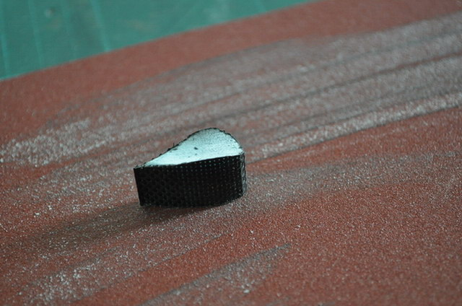
- press some hole inboard of the carbon with knife
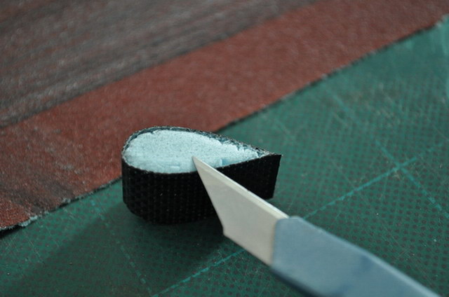
- pre-install the boom and platform and elevator, and check them fit or not
- draw a vertical line on the table

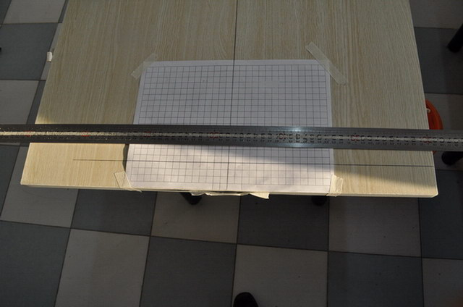
- place the elevator frame on center of the paper

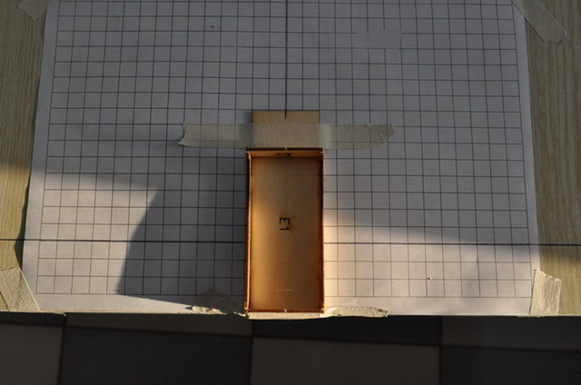
- please notice that the slot on the side of the frame must be on the paper line

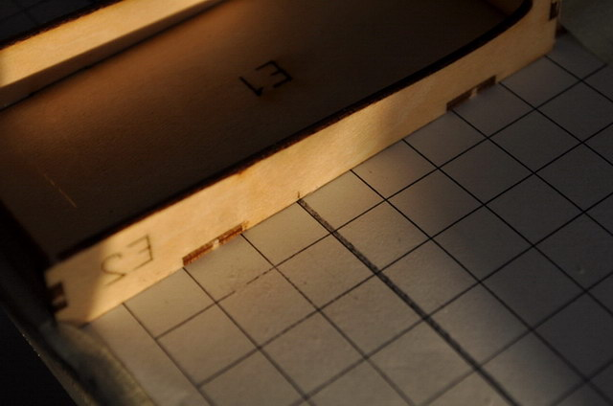
- put the elevator on the frame

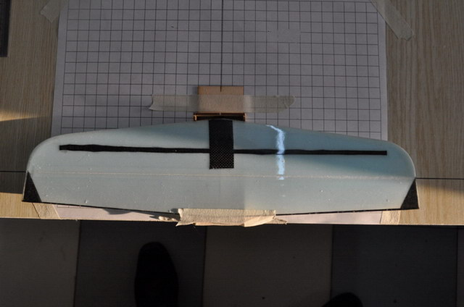
- pre-install the boom , platform , elevator. Check the fit or not, and the boom must parallel to the table.

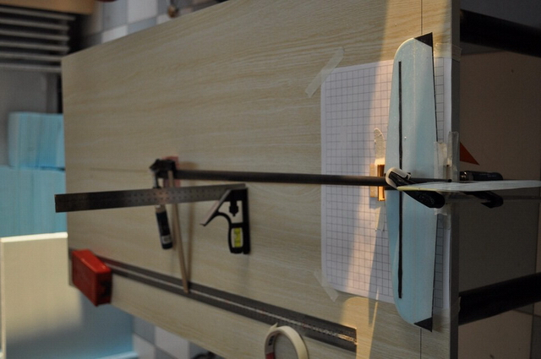
- use 6 minutes glue fix them

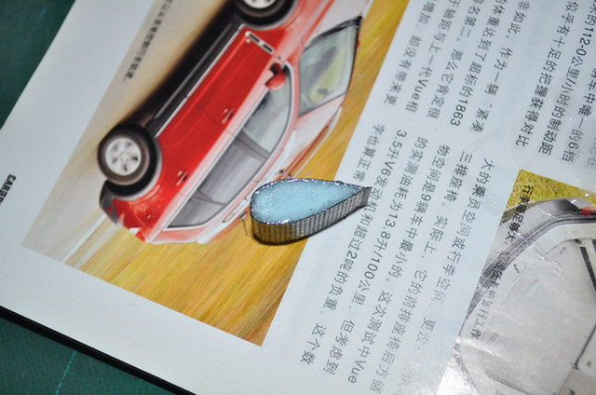
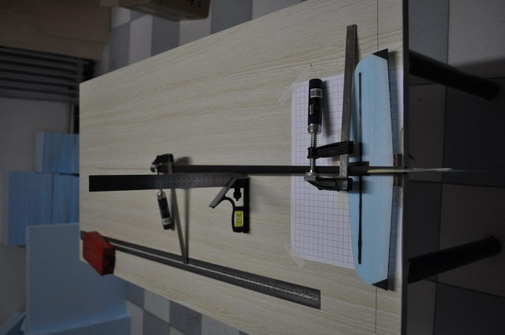
- check the following:
  - upside of the elevator airfoil fit the frame very good

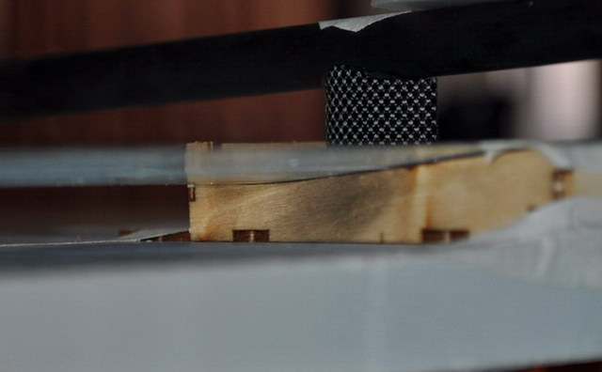
  - rudder is vertical to elevator

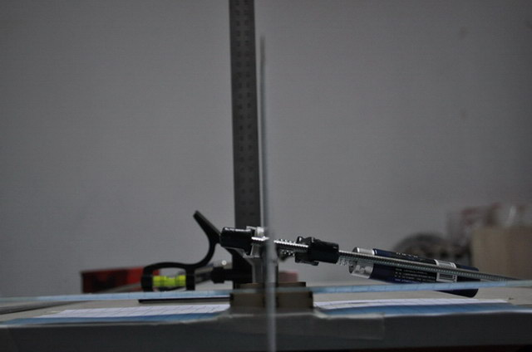
  - hinge slut parallel to the paper line

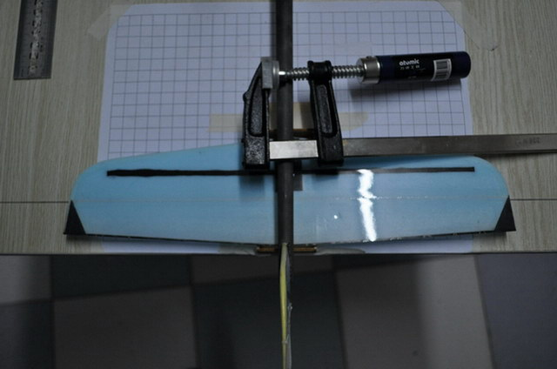
  - boom parallel to the long line on the table and table face.

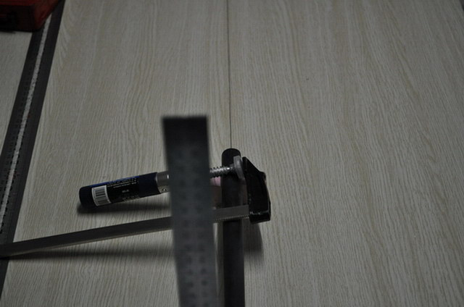

- after several minutes , cut 3 fiberglass pieces

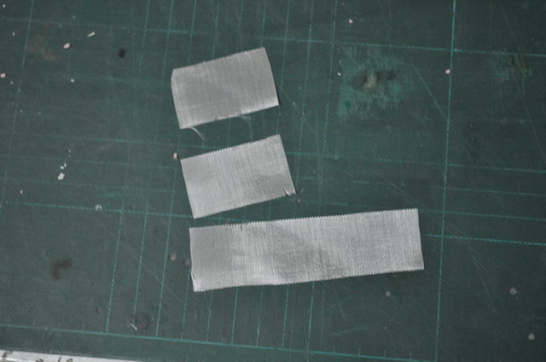
- use the epoxy

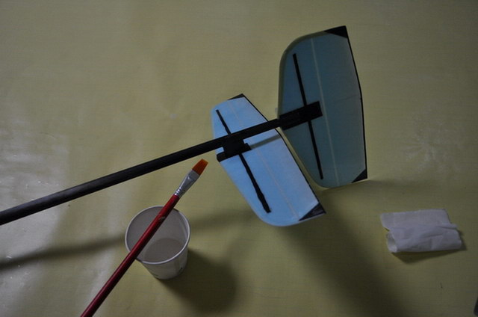
- fix the elevtor

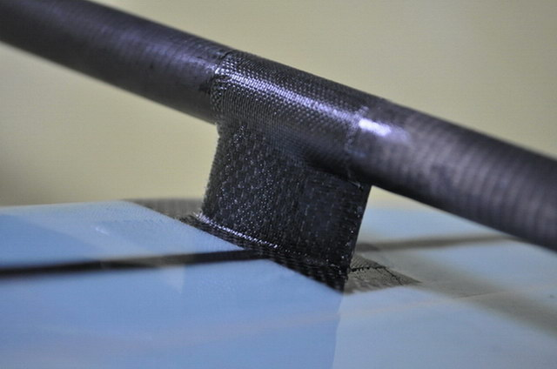
- and fix the rudder

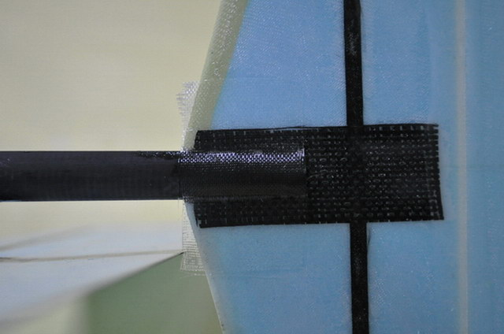
- when the epoxy solidify, cut the unwanted fiberglass

